Hazlewood Community Primary School,
Canterbury Way, Woodlands Park, Wideopen,
Newcastle Upon Tyne. NE13 6JJ.
Tel:(0191) 9178545
Email:office@hazlewoodprimary.co.uk
www.hazlewoodprimary.co.uk
Headteacher Mr. S. Bommel

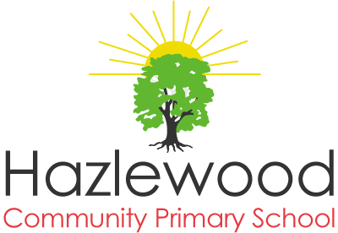

LIMITLESS POTENTIAL IGNITE PASSION EMBRACE DIFFERENCE

Monday, 11th May 2020

Dear Parents, Carers,

Following the announcement by the Prime Minister, the Department for Education is asking education and childcare settings to prepare to open for pupils in Reception, Year 1 and Year 6 from Monday 1st June 2020.

We expect to receive a published guidance today from the DFE on how we should accept more pupils into school safely. We will notify you when these plans are confirmed. School arrangements will remain as they have been in previous weeks.

Our school will continue to support our community and we will remain open for children of Key Workers and those identified by the school as requiring child care support during this period.

We will of course share the school plans with you over the next few weeks. It is vital that you are all fully involved in this process and ensure that safety for our children, parents and team will be at the heart of our thinking and planning.

Please do not hesitate to contact us, should you have any questions or worries.
office@hazlewoodprimary.co.uk

I would like to sincerely thank you all for your patience and understanding.

Stay Safe!

Yours sincerely,

Stephane Bommel
Headteacher



